June 2025

Dear Middle School students,

Welcome to St. Monica - St. Michael’s Middle School grades 6, 7, and 8!

We are looking forward to working with you as you spend another year growing and learning. Together we are going to work hard, so you reach your full potential. We will have many wonderful and fun experiences and opportunities to learn and grow in the days ahead.

You or your parents can contact us at any time over the summer, if you have any questions, by emailing. You can send any one of us an email at our school emails addresses, or through the school office.

Over the summer, we encourage you to READ, READ, READ! Find books and magazines that YOU want to read. We want you to read, but we want you to read for pleasure. This is a reminder that you have two books to read as a summer assignment. Please find the second book on your own.

To make it easier for all Middle School students, we have combined our individual Supply Lists into one that will cover all three grades. Please keep in mind that most of the items can be purchased at a Dollar or discount store and you may already have some of these things.

If you can have your supplies to begin your new school year, that would be great!

Have the BEST summer ever!

Mr. Dieckerhoff - Grade 6 HR, Social Studies
adieckerhoff@stmonica-stmichael.org

Mrs. D’Amico - Grade 7 HR, ELA (Writing and Literature)
mdamico@stmonica-stmichael.org

Mr. Sines - Grade 8 HR, Math and Science
jsines@stmonica-stmichael.org

Middle School Supply List 2025-2026

*Please write your name on your personal belongings.

In General
- 1 Box of colored pencils  - 2 Pens (blue or black, and red)  - 2 Erasers  - 1 Box of #2 pencils | - 2 Post-it note pads  - 1 Pair of scissors  - 2 Double sided-tapes  - earphones/ headphones (cheap one)
Math and Science
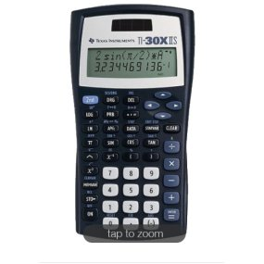
- 1 Graph paper notebook
- 2 Lined Notebooks
- 1 Composition Notebooks (Wide Ruled)
- 1 Protractor
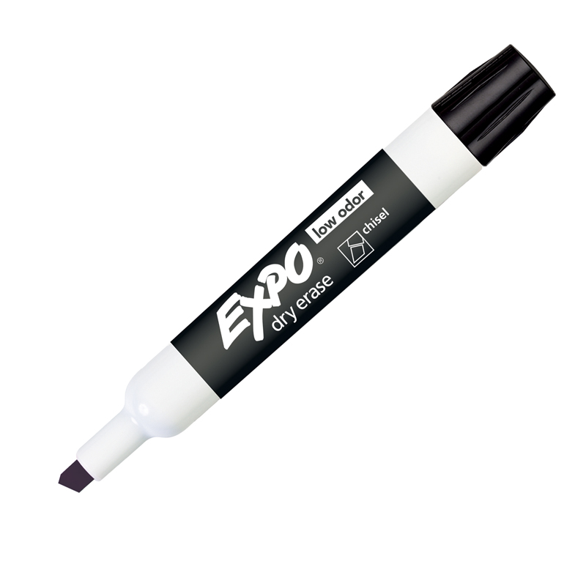
- 1 Ruler
- 1 Compass
- 1 Calculator (I recommend the Texas Instruments ti-30x)

ELA
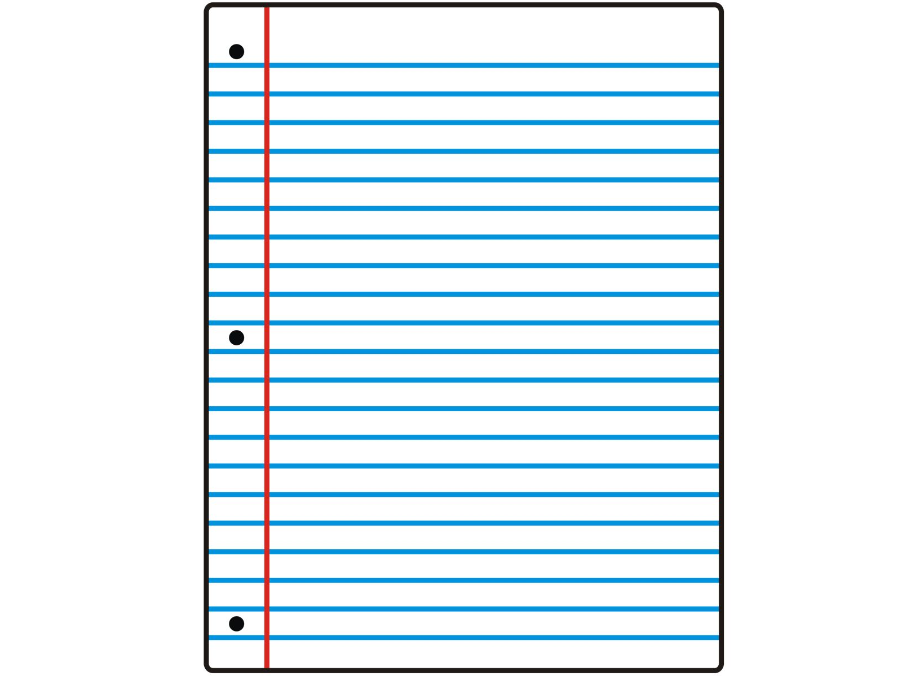
- 1 3-ring binder 2”
- 1 set of binder divider (10 tabs)
- 1 composition Notebook/ Wide Ruled <NO College Ruled>
- 1 set of highlighters (blue, green, yellow, purple, pink, orange, red, gray-this can be replaced by a pencil) MILDLINER has all colors
- 2 sets of Filler Paper (200 sheets /College Ruled) *
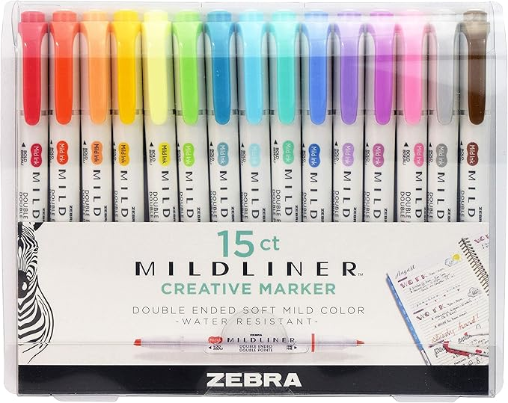
- 10 Expo Dry Erase Markers (*Chisel Tip/ Dark Colors)*
*Those items will be donated to Mrs. D’Amico

Social Studies
- 1 3-ring binder 2”
- 1 set of Filler Paper (200 sheets /College Ruled) *
*This item will be donated on the first day to Mr. D

Classroom Donation
- 3 Boxes of #2 pencils  - 1 Disinfectant Wipes | - 1 Rolls of Paper Towel  - 1 Box of Tissue

